Install the Laravel installer globally using Composer. Open a terminal or command prompt and run the following command:

composer global require laravel/installer

Run the following command to create a new Laravel project:

composer create-project laravel/laravel example-app

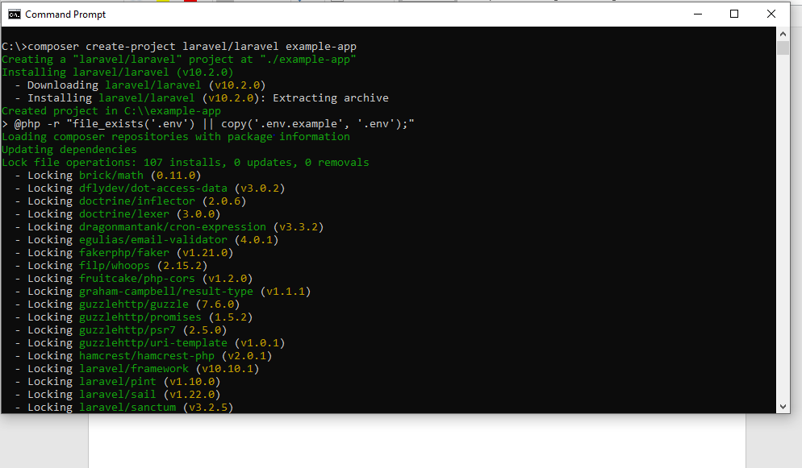

Here's a summary of the purpose of each folder in a Laravel project:

app: The app folder contains the core of your Laravel application. It holds the models, controllers, middleware, and other PHP classes that define the business logic of your application.

bootstrap: The bootstrap folder contains files responsible for bootstrapping and initializing the Laravel framework. It includes the app.php file that loads the application and sets up various configurations.

config: The config folder houses configuration files for your Laravel application. It includes files like app.php (general application configuration), database.php (database connection configuration), and mail.php (mail configuration). You can modify these files to customize your application's behavior.

database: The database folder is used for database-related files. It includes database migrations (in the migrations folder), database seeders (in the seeders folder), and the factories folder for defining model factories to generate test data.

public: The public folder serves as the web server's document root. It contains the entry point for your Laravel application, the index.php file, which handles incoming HTTP requests.

resources: The resources folder holds non-PHP resources used by your application. It includes views (in the views folder), language files (in the lang folder), and frontend assets like CSS, JavaScript, and images (in the css, js, and img folders).

routes: The routes folder contains the route definitions for your application. It includes the web.php file for defining web routes and the api.php file for defining API routes. You can create additional route files as needed.

storage: The storage folder is used to store various files generated by your application. It includes subfolders like app (for application-specific files), framework (for framework-generated files), and logs (for log files).

tests: The tests folder contains test cases for your application. It includes both unit tests and feature tests, allowing you to write automated tests to verify your application's functionality.

vendor: The vendor folder contains the dependencies installed via Composer. It includes packages and libraries required by your Laravel application. This folder is managed by Composer, and you generally don't need to modify its contents.

These folders organize different aspects of a Laravel project and provide designated locations for specific types of files and functionality, making it easier to develop, maintain, and deploy your application.

